VULNERABILITY ASSESSMENT & PENETRATION TESTING REPORT
Before You Agree - Iteration 2
Date: 17 September 2026
Scope: Vue frontend, Node.js API on EC2, AWS CloudFront/WAF, security groups, LegalBERT integration, external APIs and relevant source code
Prepared by: Raj Tandel

Table Of Contents
Index | Content | Page
1 | Purpose and method | 2
2 | Iteration 2 executive summary | 2
3 | Test evidence | 3
4 | Current findings | 4
5 | Confirmed controls | 4
6 | Impact assessment | 5
7 | Evidence screenshots | 6-8
8 | Recommendations | 9
9 | Limitations | 9
10 | References | 9
Appendix A | Iteration 1 findings and current status | 10
Appendix B | Iteration 2 unit-test result | 10

1. Purpose and method
This assessment reviews the current code, security plan, AWS screenshots and unit-test results. It checks the status of earlier findings and records new issues shown by the evidence.
• Reviewed AWS WAF, network and access screenshots.
• Reviewed API validation, caching, model and deployment code.
• Compared Iteration 1 findings with the current controls.
• Ran the unit tests: 25 passed and 4 failed.
• No intrusive or denial-of-service tests were run against production.

2. Iteration 2 executive summary
Iteration 2 adds several security controls. AWS WAF protects CloudFront, the EC2 origin only accepts approved web traffic, model files use private S3, and deployment health checks are enabled. Public SSH has been removed, Advanced DDoS protection is enabled, and CloudWatch collects deployment logs. The /api/analyze WAF rule runs in Count mode, while the API keeps its own rate limit. Four model tests still fail. Cache limits, external-response validation and browser security headers remain open.
Area | Assessment
AWS WAF | Core, SQL and DDoS protection enabled; /api/analyze is monitored
EC2 network | Only CloudFront web traffic is allowed; SSH is closed
Monitoring | CloudWatch logs confirmed; alarm evidence required
Application tests | 25 tests passed; 4 model tests failed
Previous findings | Two improved, one retained and five remain open or partial
Overall risk | Medium because model tests and some controls remain open

3. Test eVIDENCE
Check | Observed result | Meaning
AWS WAF Web ACL | Attached and receiving traffic | Confirms that edge protection is present.
WAF managed rules | IP reputation, common, known bad input and SQLi rules listed | Protects against common attacks; rule actions need retesting.
WAF protections | Core, SQL and Advanced DDoS protections enabled | Confirms active AWS protection.
WAF rate rule | Scoped to /api/analyze and shown in Count/Monitor mode | Monitors the endpoint but does not block requests.
Origin web access | Port 80 limited to AWS prefix list pl-b8a742d1 | Public web access is limited to the approved AWS path.
SSH exposure | No inbound port 22 rule | Public SSH access has been removed.
SSH retest | External connection to port 22 timed out | Confirms that public SSH is closed.
ICMP ping | Timed out | Ping is blocked or unanswered; TCP services are not tested.
CloudWatch | Deployment log events are visible | Confirms log collection; alarms are not shown.
Unit tests | 25 passed; 4 failed | The LegalBERT tests and implementation do not match.

4. Current findings
ID | Finding | Rating | Evidence | Required treatment
VA2-01 | Public SSH exposure | Resolved | Port 22 is not allowed and the SSH retest timed out. | Keep SSH closed, use AWS Systems Manager and review rule changes.
VA2-02 | WAF rate rule uses monitoring mode | Informational | The /api/analyze rule is in Count mode and DDoS protection is enabled. | Review the metrics. Use Block or Challenge if edge blocking is needed.
VA2-03 | Four LegalBERT adapter tests fail | Medium | Current Vitest run: 25 passed, 4 failed. | Align the tests with local inference and require all tests to pass.
VA2-04 | Frontend headers and CDN integrity remain open | Medium | No new header test exists. jsDelivr assets still have no SRI. | Add CSP, HSTS and frame protection. Self-host assets or use SRI.
VA2-05 | In-memory caches are not bounded | Medium | The response and rate-limit caches have no size cap or cleanup task. | Add size limits, expired-entry cleanup and memory tests.
VA2-06 | External responses lack full runtime validation | Medium | External JSON has no full size or schema validation. | Limit response size, check content type and validate required fields.
VA2-07 | Alerting evidence is incomplete | Low | CloudWatch logs are shown, but alarms are not. | Keep evidence of alarms, retention and test notifications.

5. Confirmed controls
• AWS WAF managed rules protect the CloudFront layer.
• Origin web traffic is limited to an AWS-managed prefix list.
• There is no inbound SSH rule, and the external SSH test timed out.
• Advanced DDoS, core WAF and SQL protections are enabled.
• CloudWatch collects deployment events and failure logs.
• The API uses CORS, input limits, ID checks, method controls, timeouts and safe errors.
• External requests use fixed ToS;DR, GitHub and S3 destinations.
• Policy HTML is cleaned and escaped before display.
• Private S3 delivery, local model loading and deployment health checks are enabled.

6. Impact assessment
ID | Confidentiality | Integrity | Availability | Overall
VA2-01 | Low after removing public SSH. | Low | Low | Resolved
VA2-02 | Low | Low | Low: DDoS and API limits are active. | Informational
VA2-03 | Low | Medium: incorrect results may not be detected. | Low | Medium
VA2-04 | Medium | High: changed browser assets could alter results. | Medium | Medium
VA2-05 | Low | Low | High: memory growth may restart the API. | Medium
VA2-06 | Medium | High: invalid data may affect results. | Medium | Medium
VA2-07 | Medium: incidents may be detected late. | Medium | Medium | Low

7. Evidence screenshots
Each screenshot is assessed only on what it shows. A visible AWS setting does not prove that every rule blocks traffic or sends an alert.
EV2-01 - AWS WAF Web ACL activity
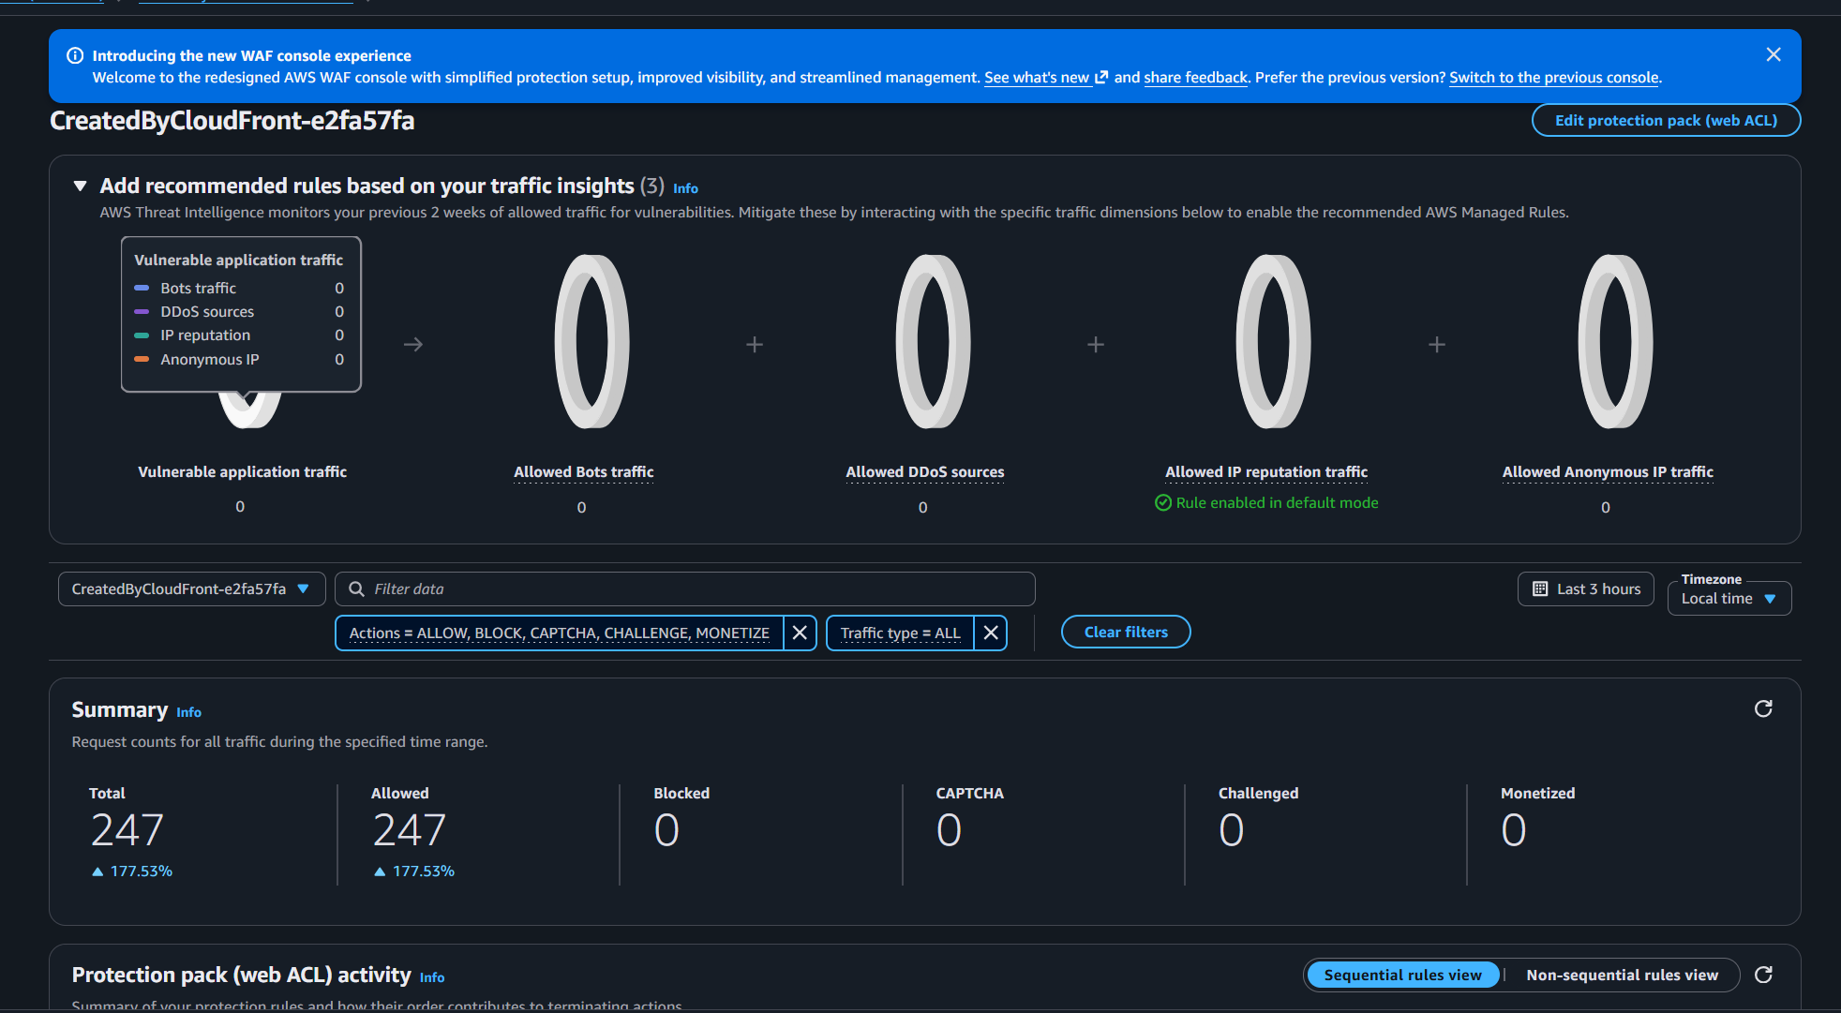
The Web ACL is active. It recorded 247 allowed requests and no blocked requests in this view.
EV2-02 - AWS WAF RULES
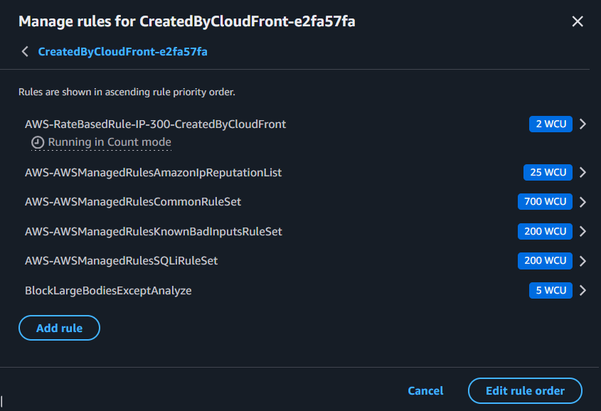
IP reputation, common threat, bad-input and SQL injection rules are listed. The /api/analyze rate rule is in Count mode.

EV2-03 - WAF PROTECTION STATUS
Core, Advanced DDoS, rate monitoring and SQL protections are enabled. The rate rule is in Monitor mode and does not block requests.

EV2-04 - EC2 INBOUND SECURITY-GROUP RULES
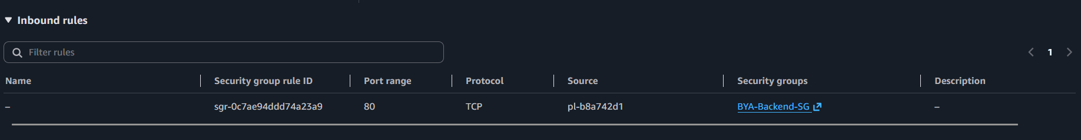
Only port 80 from the approved AWS prefix list is allowed. There is no inbound SSH rule, so the public SSH finding is closed.

EV2-05 - ICMP TEST
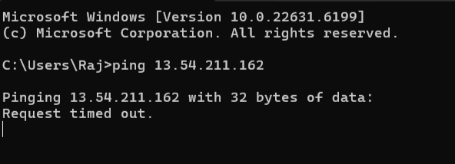
The public address did not answer ICMP echo.

EV2-06 - SSH CLOSURE RETEST
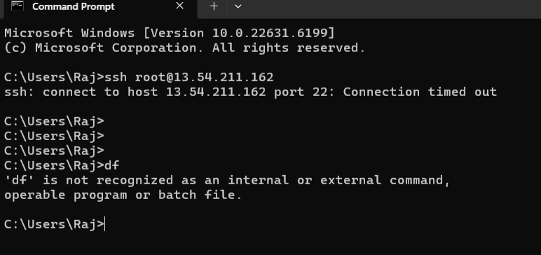
The external SSH connection to port 22 timed out.

EV2-07 - CLOUDWATCH DEPLOYMENT LOGS
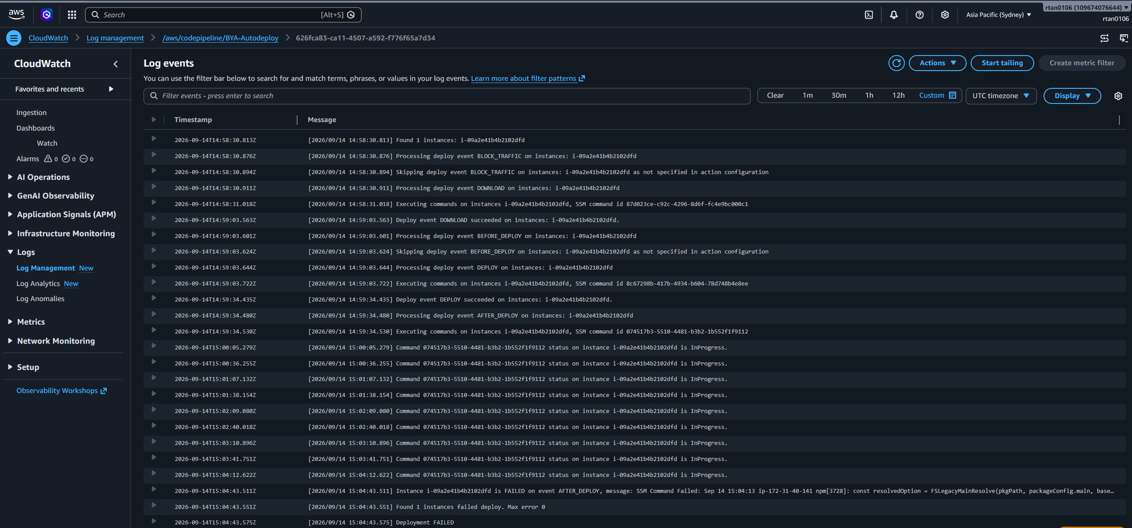
CloudWatch records CodePipeline and SSM events, including a failed deployment. This confirms central log collection.

8. Recommendations
ID | Recommendation | Priority | Reason
R-01 | Keep port 22 closed and use AWS Systems Manager | Maintain | Prevents public SSH access
R-02 | Review /api/analyze WAF metrics | Medium | Helps identify abusive traffic
R-03 | Fix the four failing LegalBERT tests | High | Reduces incorrect model results
R-04 | Add cache limits and response validation | High | Prevents memory and malformed-data issues
R-05 | Add browser headers and secure CDN resources | Medium | Reduces browser and supply-chain risks
R-06 | Retain CloudWatch logs and test alarms | Medium | Supports faster incident detection

Retesting must use an approved address and a low request rate. Do not run high-rate scans or denial-of-service tests against production. Record the date, tester, version and evidence for each closed finding.

9. Limitations
This assessment uses the screenshots, source code and a local unit-test run. It is not a full AWS audit or intrusive penetration test. The evidence does not show CloudWatch alarms, log retention, IAM policies, S3 policies, full TLS settings or a production header retest. A failed ping does not prove that the EC2 host is unreachable.

10. References
- OWASP API Security Top 10 - 2023: https://owasp.org/API-Security/editions/2023/en/0x11-t10/
- OAIC APP 11 - Security of personal information: https://www.oaic.gov.au/privacy/australian-privacy-principles/australian-privacy-principles-guidelines/chapter-11-app-11-security-of-personal-information
- ACSC Essential Eight maturity model: https://www.cyber.gov.au/business-government/asds-cyber-security-frameworks/essential-eight/essential-eight-maturity-model

Appendix A - Iteration 1 findings and current status
The original findings are kept for traceability. A finding is closed only when current evidence shows that the fix works.
Original ID | Iteration 1 finding | Iteration 2 status | Reason
VA-01 | Missing frontend browser headers | Open | No new header test or hosting evidence was supplied.
VA-02 | Process-local rate limiting | Improved | DDoS protection and WAF monitoring are enabled; the API still enforces its own limit.
VA-03 | Unbounded memory cache | Open | Entries expire, but the cache has no size cap or cleanup task.
VA-04 | CDN assets without SRI | Open | jsDelivr files still have no SRI checks.
VA-05 | Production CORS allowlist | Control retained | The exact-origin allowlist remains enabled.
VA-06 | Limited external response validation | Implemented | Fixed hosts and timeouts exist; size and schema checks are incomplete.
VA-07 | Limited security monitoring | Improved | CloudWatch logs and health checks are confirmed
VA-08 | Possible incorrect ML results | Improved | LegalBERT and privacy rules improve results, but four tests fail and model errors remain possible.

Appendix B - Iteration 2 unit-test result
Command: npm run test:unit. On 17 September 2026, 8 of 9 test files passed. Overall, 25 tests passed and 4 LegalBERT adapter tests failed. Replace this evidence after the test suite passes.

